

Roma ACC - Tunis ACC

V 2606

Sommario
Purpose 2
ACC units description 2
Rome ACC 2
Tunis ACC 3
Frequencies 3
Roma ACC 3
Tunis ACC 4
General Procedures 4
Enroute Coordination 5
LIRR->DTTC 5
DTTC->LIRR 6
Military areas coordination and management 7
Validity and Revision 7

Purpose
The purpose of this Letter of Agreement (LoA) is to define the coordination procedures to be applied between Tunis ACC and Roma ACC when providing ATS to GAT operating in IFR/VFR. The content of this LoA is approved by the concerned FIR Chiefs and its application is mandatory for all IVAO members operating on concerned position.

ACC units description

Rome ACC
The ATS unit in charge of the Roma FIR and UIR is Roma Radar and consists in three primary sectors (NE, EW, SU). LIRR_SU_CTR might be opened in two secondary sectors (LIRR_SU_CTR and LIRR_ES_CTR).
Roma Radar shall announce its actual configuration to Tunis Control as soon as possible.
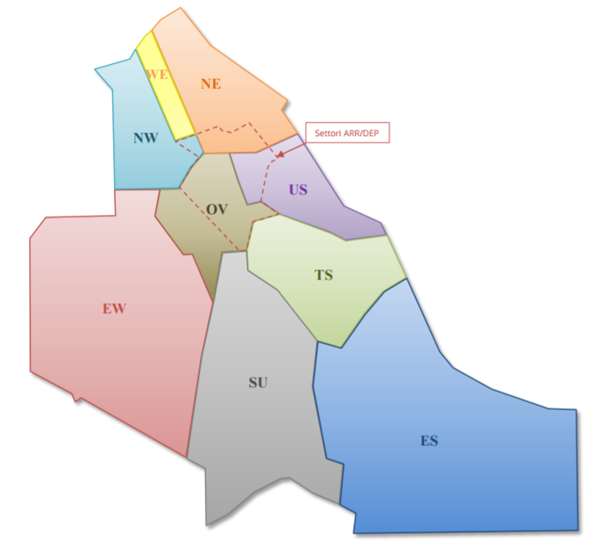

Tunis ACC
The ATC unit in charge of FIR and UIR of Tunis ACC is Tunis Control and consists of 3 sectors that are oftentimes grouped into 1 main sector.
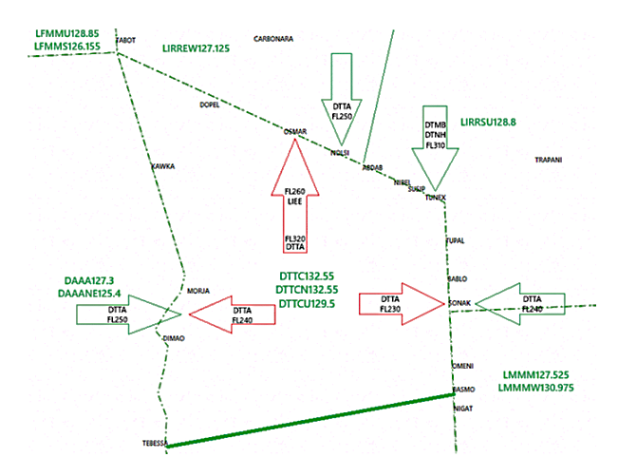

Frequencies

Roma ACC
ATC Position | Callsign | Frequency
Roma Radar | LIRR_SU_CTR | 128.800 MHz
Roma Radar | LIRR_EW_CTR | 127.125 MHz
Roma Military | LIRR_MIL_CTR | 118.750 MHz
Cagliari Radar | LIEE_APP | 118.400 MHz
Cagliari Radar | LIEE_MIL_APP | 125.950 MHz
For all CTR sectors: SFC- UNL

Tunis ACC
ATC Position | Callsign | Frequency
Tunis Radar  Boundary with LIRREW/SU | DTTC_CTR | 132.550 MHz
Tunis Radar  Boundary with LIRREW/SU | DTTC_N_CTR -FL325 | 132.550 MHz
Tunis Radar  Boundary with LIRREW/SU | DTTC_U_CTR FL325+ | 129.500 MHz
Tunis Radar  (no boundary with LIRR) | DTTC_S_CTR | 129.300 MHz
Tunis Information | DTTC_FSS | 128.900 MHz
For all CTR sectors: SFC- UNL

General Procedures
Traffic in sequence shall be handed over with minimum spacing of 10 NM. This separation must be constant (aircraft restrained to the same speed) or increasing (succeeding aircraft is not faster). Coordination of speed control should be granted via radar labels and does need the approval and acknowledgement from the receiving sector.
Traffic shall be handed over as soon as practicable and whenever possible, at least 3000 ft before reaching the cleared flight level. If the transfer point is not defined in this LoA, at least 10 Nm before the airspace limits.
All traffics shall be handed over properly separated and clear of any conflict. Unless the receiving ATC unit issue a clearance modifying the route, altitude or speed, the transferring sector remains responsible for separation.

Enroute Coordination

LIRR->DTTC
Roma ACC will transfer aircraft cleared to ODD flight levels, as RFL, except as provided in the following table.
FIX | Flight Level | Remarks
NOLSI | 250 | DEST DTTA  TUC/MANEX/MARSA  possible
ABDAB | 230
SUSIP/TUPAL | 290
TUPAL | 290 | DEST DTNH  NBA/ATLEL/MOVAR  possible
TUNEX | 310

DTTC->LIRR
Tunis ACC will transfer aircraft cleared to EVEN flight levels, as RFL, except as provided in the following table.
FIX | Flight Level | Remarks
OSMAR | 260  320 | ARR LIEE  DEP DTTA  CAR/CORSI/ELB/BETOT  LATAN..  possible
NIBEL | 280
SUSIP
TUPAL
BABLO | 300 | DEP DTMB
TUPAL/BABLO | 320 or BELOW | DEST LICJ → FL190  MEGAN/TRP  possible  DEST LICT → FL150  MEGAN/LOPKO/TRP/  MORUX/EKTOR  possible

Tunis ACC and Roma ACC coordinate actively for DCTs within respective sectors and beyond.
The segment NIVAB-TABOT is delegated to Tunis ACC and traffic transfer is LFMM-DTTC-LFMM. The French (LFMM) are often misinformed about this and neglect any coordination in case of event or just everyday use.

Military areas coordination and management
NIL

Validity and Revision
This vLoA is effective as of the effective date until a future revision.
If inconsistencies are found between this document and the national aeronautical legislation, the corresponding fixes, airways, limits, minimums, etc. in force in AIP Italy must be considered. If such correspondences do not exist, it will be necessary to proceed by applying occasional derogations.

